TIMO wants a forever home!!!!

I am a neutered male and current on all shots. I am 6 years old and healthy. My foster Mom does not know my exact breeding but my veterinarian says I am at least hound and husky with big pointy ears. I am very curious and have lots of energy. I have a thin coat and good feet and teeth. I weigh 35- 40 lbs. I grew up in a dog yard and love to run. I spent many years working with kids in a program at a school. I run in a team in any position though I have not tried lead in a team. Although I get really excited, I am easy to handle and want to always do the right thing! I love attention and really love to play with other dogs.

I was homed for two years with a wonderful owner but she cannot keep me due to medical issues and a job change with long hours. She wants the best possible home for me now. She describes me as: “Super sweet; there’s not a mean bone in this boy’s body, he loves everyone; I’ve never seen him raise his hackles with any dog or person. He has run in double and single lead when jogging, biking and skijoring - he did great. He is very fast and he is an honest, hard worker. Great eater & easy keeper. He lives in a yard with 6’ fence and has never challenged it. He is also fine on a chain. He loves his doghouse full of straw. He is super happy when he comes indoors even though he really enjoys the outdoors. He does good off leash and with a little work, he would be great. He would be wonderful in a junior’s team or with a family as he loves kids, but would be just as happy as someone’s all-the-time adventure buddy.

My foster Mom has me now sleeping in the house every night with other dogs and I like it. She says I need an active owner, who also has another dog so I don’t get lonely. I want a to be loved and have a fun life. OH I guess I am also a movie star! See this link and me running at the 2:20 mark: https://www.nps.gov/media/video/view.htm?id=0782EFA1-FCE7-98AD-C4C4FDFF6133C60E (NPS post of ALASKA YOUTH: MUSHING WITH PRIDE)

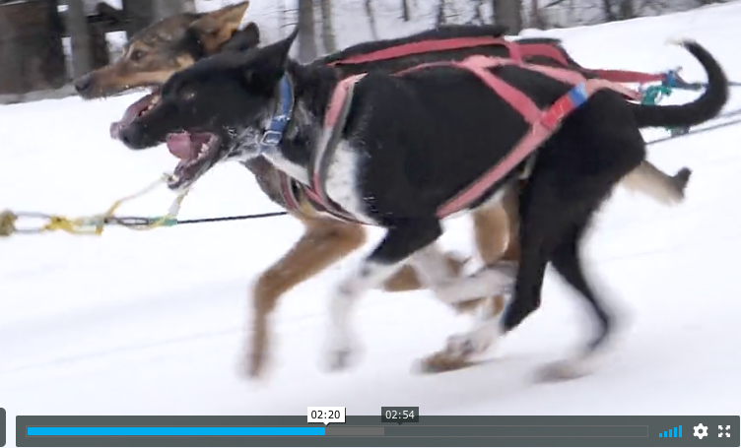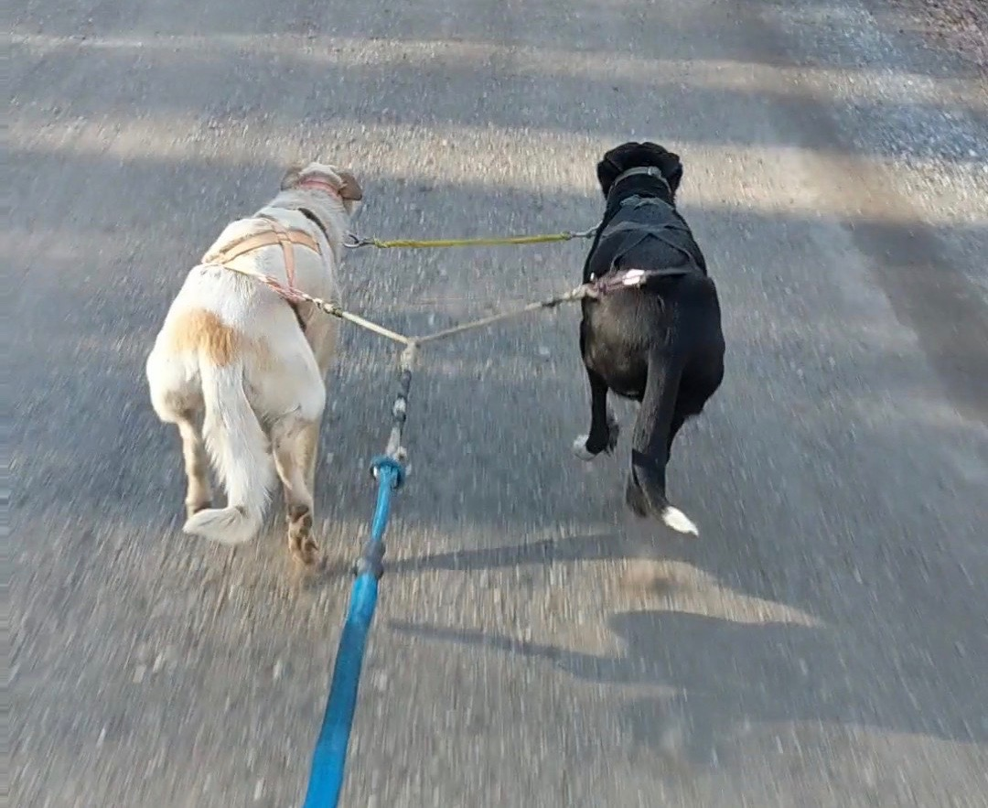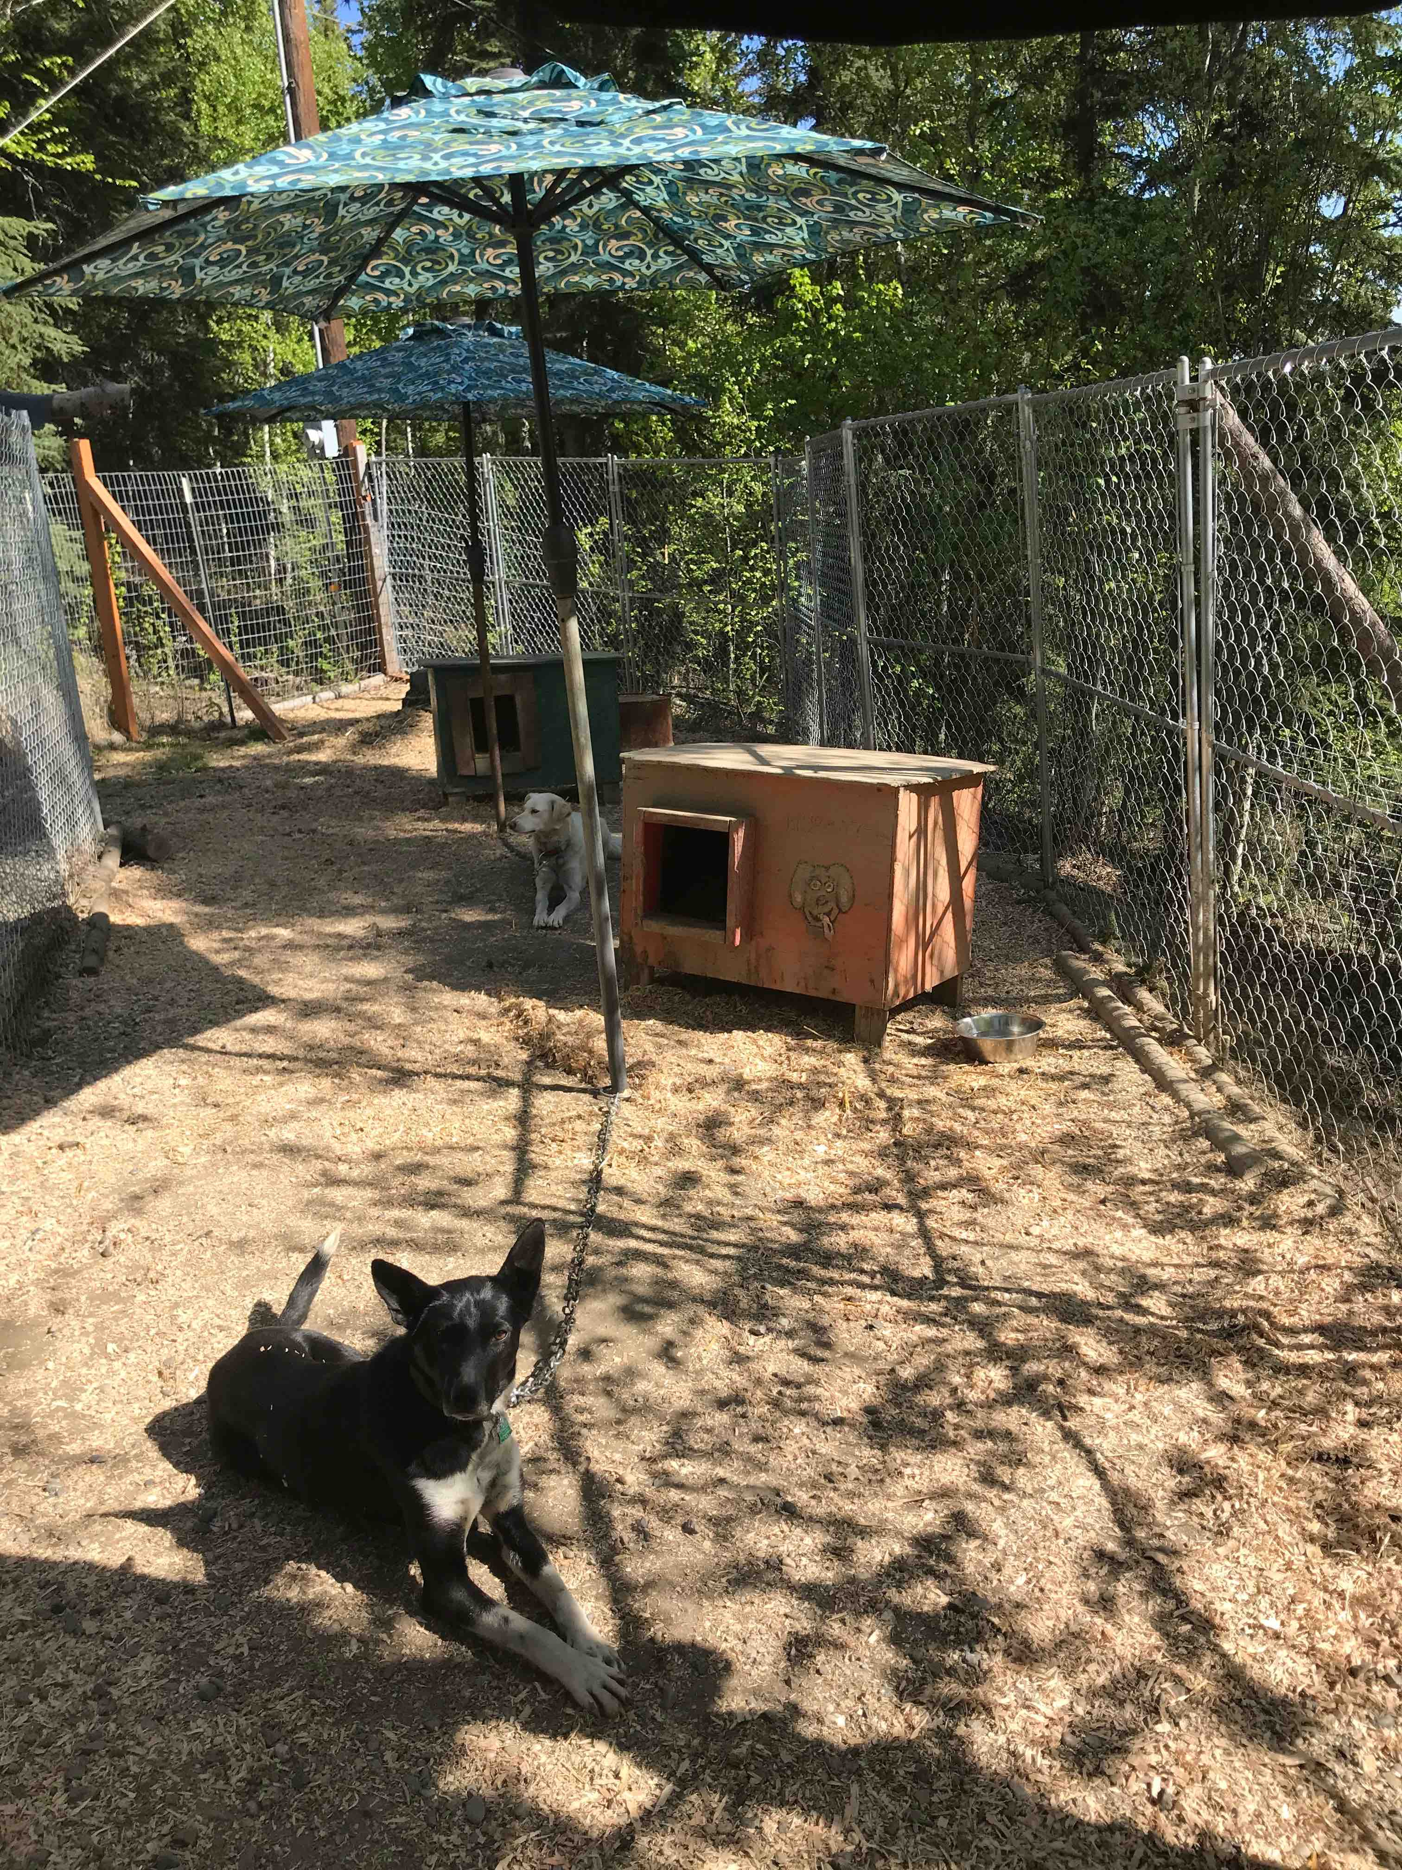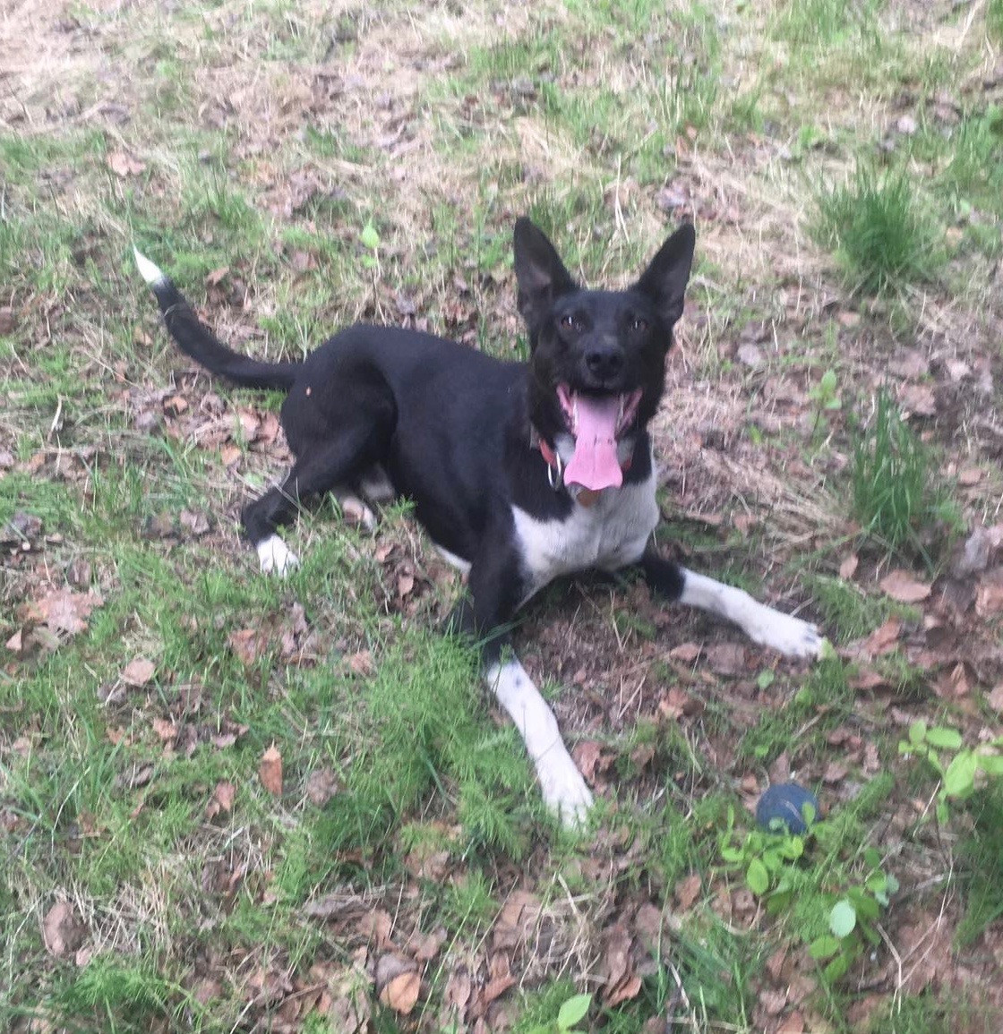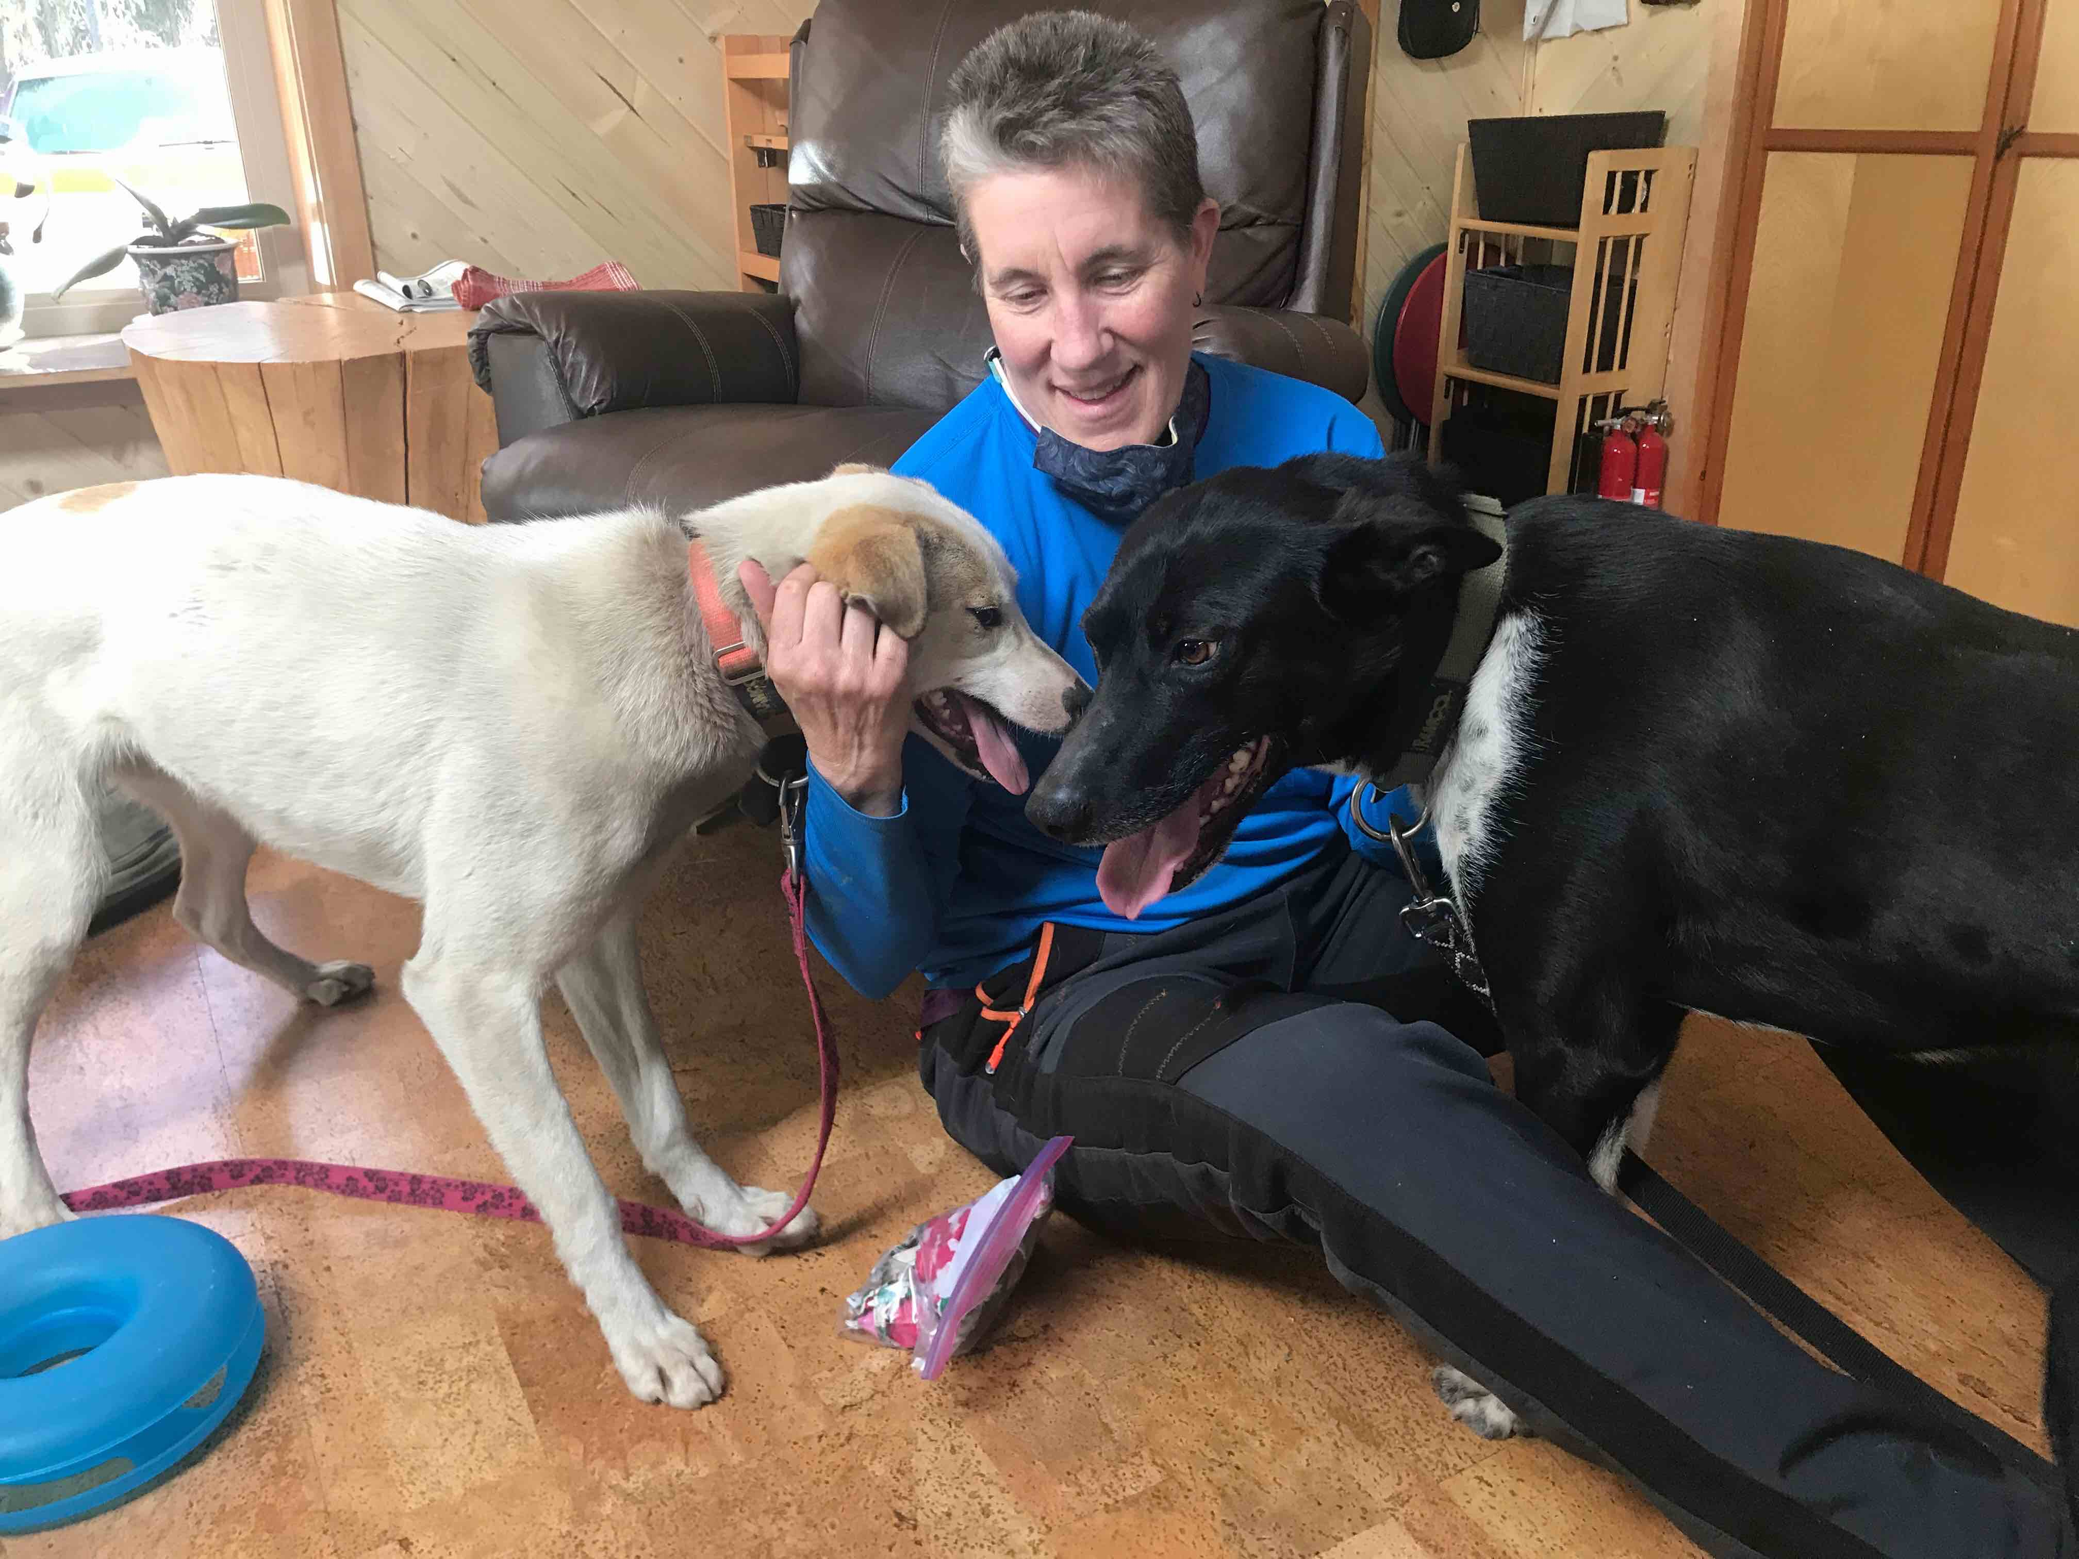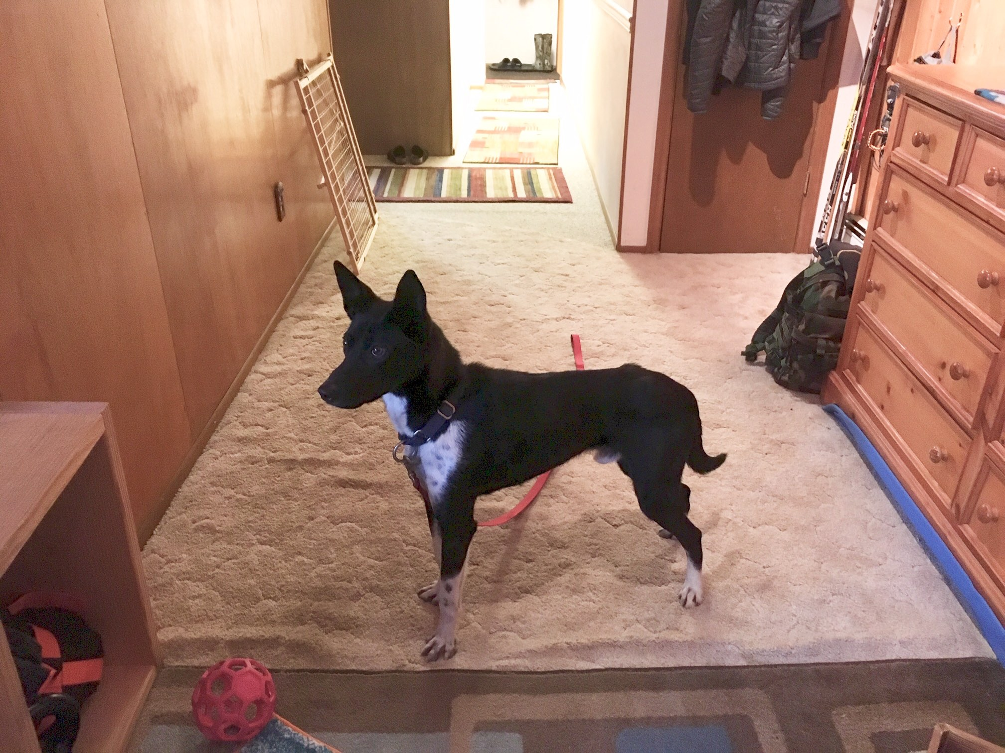

For more info & to meet me, contact Kathy: 907-697-3655 / youthandsleddog@gmail.com

